class04.r

neuro

2024-04-11

# This is just a text file  
x <- 1:50  
plot(x, sin(x))

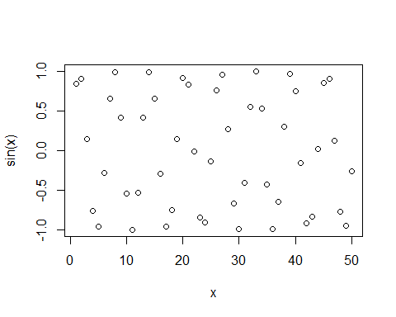

plot(x,sin(x), type = "l", col = "dodgerblue3", lwd = "3")

